Explainable AI System for Cardiovascular Disease Detection and Diagnosis

Project ID - R26-IT-083
Cardiomegaly Detection with XAI and Automatic Report Generation

Project Proposal Report
Raagul Gananathan – IT22130020

B.Sc. (Hons) Degree in Information Technology Specialized in
Information Technology

Department of Information Technology

Sri Lanka Institute of Information Technology Sri Lanka

March 2026

DECLARATION
I declare that this is my own work, and this proposal does not knowingly incorporate any material previously submitted for a degree or diploma at any other university or higher education institution, nor does it contain any material that has been previously published or written by another person apart from where proper acknowledgment is given in the text.

Name | Student ID | Signature
Raagul Gananathan | IT22130020

The above candidate is conducting research for their undergraduate Dissertation under my supervision.

Name | Date | Signature
Ms. Dushanthi Kuruppu

ABSTRACT
Heart disease is the leading cause of death in the world, and one of the earliest signs seen on a chest X-ray is an enlarged heart, known as cardiomegaly. The chest X-ray is the cheapest and most common test that shows this, but every film must still be read by a trained radiologist. Because there are far fewer radiologists than films waiting to be read, reports and treatment are both delayed.
Computer systems that read chest X-rays already exist, but three problems keep them out of daily hospital use. Most give only a score and do not show which part of the picture produced it, so the doctor cannot check the answer. Systems that write a draft report often copy phrases such as “unchanged from the previous study” although no earlier study was given to them. They are also judged by one overall accuracy figure, which hides the fact that they are weaker on X-rays taken at the bedside, the films of the sickest patients.
This proposal describes a chest X-ray reading assistant that will deal with all three problems together. It will detect cardiomegaly and the related chest findings, draw a heat map over the area that produced the decision, and write a short draft findings report containing only what the image can support. The new part of this research is a reliability layer that will measure how well the system works on bedside and standing films separately, and mark the less certain readings for a doctor to check first.
The system will be developed in Python and trained on public, de-identified chest X-ray data from PhysioNet. The expected outcome is a working prototype that gives a faster first read, an explanation the doctor can check, and an honest statement of how far each result can be trusted.

Keywords: Chest X-ray, Cardiomegaly, Explainable AI, Automatic report generation, Model reliability

ACKNOWLEDGEMENT
I would like to sincerely thank my supervisor, Ms. Dushanthi Kuruppu, for the guidance and encouragement given while this research topic was being shaped. Her advice helped me to narrow a very broad idea into a problem that is both practical and worth studying.
I am also grateful to the Department of Information Technology of the Sri Lanka Institute of Information Technology for the academic support and the review process that made this proposal possible, and to my team members for their cooperation on the shared parts of the system.
I would further like to acknowledge the Massachusetts Institute of Technology Laboratory for Computational Physiology and the Beth Israel Deaconess Medical Center for making a large, carefully de-identified collection of chest X-rays and radiology reports openly available through PhysioNet. Research of this kind would not be possible without such shared medical data.
Finally, I thank my family for their constant support throughout my studies.

TABLE OF CONTENT
DECLARATION 2
ABSTRACT 3
ACKNOWLEDGEMENT 4
TABLE OF CONTENT 5
LIST OF TABLES 7
LIST OF FIGURES 8
LIST OF ABBREVIATIONS 9
LIST OF APPENDICES 10
1. INTRODUCTION 11
1.1 Background and Context 11
1.2 Literature Review 12
1.3 Research Gap 13
2. OBJECTIVE 14
2.1 Main Objective 14
2.2 Specific Objectives 14
3. METHODOLOGY 15
3.1 Research Approach 15
3.2 Technical Methods and Algorithms 15
3.3 Tools and Platforms with Justification 16
3.4 Data Collection and Ethical Considerations 16
3.5 Validation Strategy and Performance Metrics 17
4. HIGH-LEVEL SYSTEM ARCHITECTURE 18
4.1 Overview of the Proposed Solution and Its Components 18
4.2 System Diagram of Components 18
4.3 Highlight of the Individual Component and Its Parts 19
4.4 Component Interactions 19
4.5 Data Flow Explanation 20
4.6 Scalability and Security Considerations 20
5. USER REQUIREMENTS 21
5.1 Stakeholder Identification 21
5.2 Functional Requirements 21
5.3 Non-Functional Requirements 22
6. COMMERCIALIZATION PLAN 23
7. BUDGET AND JUSTIFICATION 24
8. WORK BREAKDOWN STRUCTURE (WBS) 25
8.1 Task Breakdown 25
8.2 Timeline Alignment and Workload Distribution 25
9. GANTT CHART 26
10. REFERENCES LIST 27
11. APPENDICES 28
Appendix A: Preliminary Interface Layout 28
Appendix B: Risk Analysis 28
Appendix C: Data Access and Ethical Documents 29

LIST OF TABLES
Table 1: Comparison of existing work with the proposed component
Table 2: Estimated budget for the component
Table 3: Risk analysis

LIST OF FIGURES
Figure 1: System diagram of components
Figure 2: Data flow of the individual component
Figure 3: Task breakdown
Figure 4: Gantt chart
Figure 5: Preliminary interface layout

LIST OF ABBREVIATIONS
Abbreviation | Full Form
AI | Artificial Intelligence
AP | Anteroposterior (X-ray taken at the bedside while lying down)
CNN | Convolutional Neural Network
CVD | Cardiovascular Disease
CXR | Chest X-Ray
Grad-CAM | Gradient-weighted Class Activation Mapping
ICU | Intensive Care Unit
MIMIC-CXR | A public chest X-ray database released through PhysioNet
PA | Posteroanterior (X-ray taken while the patient is standing)
SDG | Sustainable Development Goal
UI | User Interface
XAI | Explainable Artificial Intelligence

LIST OF APPENDICES
Appendix A: Preliminary interface layout
Appendix B: Risk analysis
Appendix C: Data access and ethical documents

1. INTRODUCTION

1.1 Background and Context
Cardiovascular disease is the largest single cause of death in the world. The World Health Organization estimates that about 17.9 million people die from it every year, which is close to one third of all deaths recorded worldwide [1]. One of the changes that can be seen early is an enlarged heart, known as cardiomegaly. An enlarged heart is not a disease on its own; it is a sign that the heart has been working under strain for a long time, for example because of high blood pressure, a leaking valve or heart failure. If it is found early the patient can be treated before the damage becomes permanent, so the cost of missing it is high.
The chest X-ray is the test that usually shows this first. It is cheap, it takes only a few minutes, it uses a low dose of radiation, and almost every hospital already owns the equipment. Because it is so easy to order, it is also the most common imaging test in the world, and every single film has to be looked at and reported by a trained radiologist. The number of chest X-rays taken each day grows faster than the number of radiologists available to read them. In Sri Lanka, diseases of the circulatory system remain among the leading causes of hospital death reported by the Ministry of Health [2], while the number of qualified radiologists is small compared with the number of studies produced daily, especially in district and base hospitals. Films are therefore held in a queue, and a report that could have changed treatment on the same day may only be issued days later.
Three groups are affected by this delay. Patients are affected because a late report means late treatment, and because a finding missed on a busy day may not be picked up again until the patient becomes much more unwell. Radiologists are affected because reading a long list of films under time pressure is tiring, and tiredness is a known cause of reading errors. Junior doctors in intensive care and emergency units are affected because they often have to act on a film immediately, before the formal report is written.
There is one more point that is easy to overlook, and it is central to this research. A chest X-ray can be taken in two ways. If the patient can stand, they stand facing the plate and the beam passes from the back of the chest to the front. This is the standing film, and it is the type radiologists prefer. If the patient is too sick to stand, a portable machine is brought to the bed and the beam passes from the front of the chest to the back while the patient lies down. On this bedside film the heart is further from the plate, so it is projected larger than it really is and a normal heart can look enlarged. The shoulder blades lie over the lung fields, fluid spreads along the back of the chest instead of collecting at the bottom, and portable machines produce a lower quality picture. Bedside films are therefore harder to read, and they come from the patients who most need a correct answer.
The idea behind this component is to build a reading assistant that helps with all of these problems at once. It will detect cardiomegaly and the related chest findings, show the part of the image that produced the decision as a heat map, and prepare a short draft findings report for the radiologist to edit. In addition, and this is the new part of the work, it will measure and report how reliable its answer is for the way that particular X-ray was taken, and mark the less reliable readings so that a doctor looks at them first.
The work supports Sustainable Development Goal 3, Good Health and Well-being, and in particular the target of reducing early death from non-communicable diseases, because faster and more consistent reading of chest X-rays leads to earlier detection of heart disease. It also supports Goal 10, Reduced Inequalities, because the reliability layer is designed to protect the group of patients that current systems serve worst. Within the faculty, the component belongs to the Machine Learning and Artificial Intelligence research cluster and overlaps with health informatics through its clinical application.

1.2 Literature Review
Automatic reading of chest X-rays became practical when large labelled collections appeared. Wang and colleagues released ChestX-ray8, a hospital-scale collection with labels for eight common chest findings taken automatically from report text, and showed that a deep learning model could learn them [6]. Irvin and colleagues released CheXpert, which added a label for uncertain cases and a tool that reads findings out of report text [4]. Johnson and colleagues released MIMIC-CXR, which pairs 377,110 chest X-rays from 65,379 patients with the original radiology report for each study and with the record of how each image was taken [3]. That pairing is what makes both finding detection and report writing possible from one source. Building on this kind of data, Rajpurkar and colleagues showed with CheXNet that a deep model could match a panel of radiologists on pneumonia detection [5].
Explaining what such a model decided is a separate line of work. Selvaraju and colleagues proposed Grad-CAM, which produces a heat map showing which parts of an image contributed most to a chosen output, and which can be applied to a trained model without changing it [7]. It has become the standard explanation method in medical imaging. Arun and colleagues, however, tested several such methods on chest X-rays against expert markings and found that the maps are often unstable [8]. Their conclusion matters for this proposal: a heat map should be used as a check for obvious error, confirming that the model looked at the heart and not at a label in the corner, and not as proof that the answer is correct.
Writing a report automatically from an image has also been studied for several years, and the most relevant result for this component comes from Ramesh and colleagues. They showed that report writing systems routinely produce references to earlier studies that they were never given, and that removing those sentences from the training text is an effective fix [9]. This is a safety problem rather than a scoring problem, because a false statement such as “no change since the previous film” can reassure a doctor about something that was never checked.
A fourth line of work asks whether these systems perform equally well for every patient. Zech and colleagues showed that a pneumonia model can learn features of the hospital that produced the image rather than features of the disease, and that its accuracy falls sharply at a new site [12]. Seyyed-Kalantari and colleagues measured chest X-ray classifiers across patient groups and showed that they systematically miss disease in under-served patients [10]. Work on the way the image was acquired is much thinner. Pereira and colleagues studied the difference between the two types of chest X-ray directly and proposed to remove it by retraining the model so that it can no longer tell the two apart [11]. Their method reduced the reported gap, but it needs the whole model to be retrained, it costs some accuracy, and it was tested on a single collection that does not contain radiology reports.

1.3 Research Gap
The review above shows that the individual pieces exist, but that no published system brings them together, and that one important piece is missing altogether.
First, detection, visual explanation and draft report writing are studied separately. A doctor working in a real ward needs all three at once, on the same film, in one screen. Second, the work on whether these systems treat every patient equally concentrates on who the patient is, such as age, sex or ethnicity. It does not look at how the picture was taken, even though that is recorded in the file for every study and is known to change what can be seen. Third, the one study that does deal with the two types of film treats the difference as a fault to be removed by retraining [11]. Nobody has tested whether a far simpler step, setting the decision level separately for each type of film, which costs nothing and needs no retraining, gives a comparable improvement. Fourth, no existing system tells the user how much a particular answer can be trusted. Every result is presented with the same authority, whether it came from a clean standing film or from a poor bedside film taken in an intensive care unit.

Table 1: Comparison of existing work with the proposed component
Capability | Detection  models  [4]–[6] | Explanation  studies  [7], [8] | Report writing  studies  [9] | Fairness  studies  [10], [12] | Pereira  et al.  [11] | Proposed  component
Detects cardiomegaly and related findings | Yes | No | No | Yes | Yes | Yes
Shows the image area behind the decision | No | Yes | No | No | No | Yes
Writes a draft findings report | No | No | Yes | No | No | Yes
Report free of unsupported claims about earlier studies | – | – | Partly | – | – | Yes
Accuracy reported for bedside and standing films separately | No | No | No | No | Yes | Yes
Decision level set per film type, with no retraining | No | No | No | No | No | Yes
Reliability note shown to the user for each case | No | No | No | No | No | Yes
The novelty of this component is that it treats the way the image was taken as a real part of the system instead of a nuisance to be hidden. On the same data and the same model it will compare a free adjustment of the decision level against the published approach of retraining, it will separate the part of the measurement that depends on the decision level from the part that does not, and it will turn the result into a warning that sends the least reliable readings to a radiologist first. Each of these answers a limitation already shown in published work [8]–[12].

2. OBJECTIVE

2.1 Main Objective
To develop an explainable chest X-ray reading assistant that detects cardiomegaly and the related chest findings, shows the area of the image behind each decision as a heat map, produces a draft findings report limited to what the image can support, and reports how reliable each result is for the way that X-ray was taken, so that less reliable readings are marked for a radiologist instead of being presented as equally trustworthy.

2.2 Specific Objectives
SO1. To prepare a clean dataset of chest X-rays in which no patient appears in more than one part of the training, validation and testing data, and to remove from the training reports every sentence that the image alone cannot support.
SO2. To build an image preparation step that suits X-ray images rather than ordinary photographs, and to confirm by comparison which preparation choices help and which harm.
SO3. To develop a detection model for cardiomegaly and the related chest findings, and to report its accuracy together with a confidence range rather than as a single unqualified number.
SO4. To add a heat map explanation for each detected finding and to check on a sample of cases that the highlighted area falls in the expected part of the chest.
SO5. To develop a draft report writer whose output is compared against a fixed sentence baseline, so that any improvement is shown to come from the image, and to confirm that the generated text never refers to a study that was not provided.
SO6. To measure the performance of the system separately for bedside and standing X-rays, to compare two ways of responding to any difference found, and to deliver a reliability warning for each case based on the result.

3. METHODOLOGY

3.1 Research Approach
This study uses a Design Science research approach together with an experimental evaluation method. The Design Science approach is chosen because the main output of the work is an artefact, that is a working software component built to solve a stated practical problem, and because the work proceeds in cycles of building, measuring and improving.
The experimental method is used because the central question of this component is a comparison. Two different ways of responding to the difference between bedside and standing X-rays will be applied to the same model, the same data and the same split, and their effects will be measured against each other. Every experiment will be defined before it is run, with the measure and the comparison stated in advance, and any difference that is reported will be given with a confidence range so that a small change is not mistaken for a real one.

3.2 Technical Methods and Algorithms
The system will be built in five parts. In the first part, image preparation, every chest X-ray will be resized to a fixed square size and its brightness and contrast corrected against its own values, because X-ray brightness varies with the machine and the exposure settings used. Only changes that a real X-ray could plausibly show, such as a small rotation, will be applied during training.
In the second part a convolutional neural network will be trained to detect the findings. The model will start from weights learned on a large general image collection and will then be trained further on chest X-rays. It will produce one score between zero and one for cardiomegaly and one for each related chest finding, because these findings often appear together on the same film and a design that allows only one answer would be wrong for a real patient. Rare findings will be given more weight during training so that they are not ignored.
The third part is the explanation. Heat maps will be produced with Grad-CAM, which measures how strongly each area of the image contributed to a chosen output and shows the result as a coloured overlay on the original film [7]. Grad-CAM is chosen because it works on the trained model without changing it, so the explanation describes the model that is actually used.
The fourth part is the draft report. A language model that has already been trained on medical text will be connected to the same image features and will learn to write a short findings paragraph. It will be trained only on the cleaned report text described in Section 3.4, so that it never sees, and therefore never learns to produce, a reference to a study it was not given. Because a fixed sentence that ignores the image entirely can score surprisingly well on the usual text measures, the score of such a fixed baseline will also be computed and the writer will be judged on how far it exceeds that baseline.
The fifth part carries the new contribution and will be done in four steps. First the accuracy of the detection model will be measured separately for bedside and standing X-rays, for every finding, with a confidence range, so that it is known whether a difference exists and how large it is. Second the level at which a score is called positive will be fitted separately for each type of film on the validation data and then applied unchanged to the test data; this costs nothing and needs no retraining. Third the published approach of retraining the model so that it can no longer tell the two types of film apart [11] will be rebuilt on the same data, and its effect and its cost in accuracy recorded, so that a free method and an expensive one are compared fairly. Fourth, whichever response the measurements support will be turned into a reliability band attached to every result and a warning that marks the least reliable cases for a radiologist to read first.

3.3 Tools and Platforms with Justification
Python will be used as the main development language because it has the strongest library support for artificial intelligence work. PyTorch will be used to build and train the models, as it is flexible, widely used in medical imaging research and produces results that others can reproduce. The report writer will be built with the Hugging Face Transformers library, which provides tested implementations of medical language models. NumPy, pandas and scikit-learn will be used for data handling and for the accuracy measures.
Training will run on Google Colab, which gives access to a modern graphics processing unit without buying hardware and charges only for what is used, and the data and saved models will be kept on Google Drive so that nothing is lost if a session disconnects. The finished component will be made available through a small web service built with FastAPI and connected to the group web interface, and all code will be kept under Git version control. All of these tools are open source and free, which keeps the cost of the project low.

3.4 Data Collection and Ethical Considerations
The data for this research will come from MIMIC-CXR, a public chest X-ray database published by the Massachusetts Institute of Technology Laboratory for Computational Physiology and made available through PhysioNet [3]. It contains 377,110 chest X-ray images from 227,835 imaging studies of 65,379 patients treated at the Beth Israel Deaconess Medical Center. Every study comes with its original radiology report and with the record of how the image was taken, which is exactly what this component needs. The finding labels released with the collection [4] will be used as the starting point. A second public collection, ChestX-ray8 [6], will be used only as an outside check, so that behaviour seen on one collection can be tested on another gathered at a different hospital.
Only frontal X-rays will be kept, because the findings of interest are assessed on the frontal view. The record of how each image was taken will be read from the file and stored as a separate column, so that bedside and standing films can be compared later; this value is read, not guessed from the picture. The data will then be split by patient rather than by image, and the split will be checked automatically so that no patient appears in more than one part. Finally, the report text used for training will be cleaned so that sentences the image alone cannot support, mainly comparisons with earlier films, are removed, following the approach of Ramesh and colleagues [9].
Access to MIMIC-CXR is granted only to registered users. It will be requested through PhysioNet in the normal way, by completing the required online training course on working with health data, submitting the training certificate and signing the data use agreement. No patient will be contacted, no hospital records will be requested and no new images will be collected for this project. The data is already de-identified at source, with dates shifted and identifying details removed, so no patient can be recognised from the files used. The agreement forbids any attempt to identify a patient and forbids passing the data to anyone else, and these conditions will be followed. Because the work uses only an existing public de-identified collection and involves no human participants, no further ethical clearance is required. The prototype will carry a clear notice stating that it is a research tool, that it is not an approved medical device, and that a qualified radiologist must review and sign every result.

3.5 Validation Strategy and Performance Metrics
Validation will follow a strict separation of roles. The training data will be used to fit the model, the validation data to choose between options and to set any decision level, and the test data will be used once, at the end, only to report the result. No decision of any kind will be made by looking at the test data.
The detection model will be measured by the area under the receiver operating characteristic curve, which describes how well the model separates patients who have a finding from those who do not without depending on where the decision level is set, and this will always be reported with a confidence range and separately for the two types of X-ray. Sensitivity and specificity at the chosen decision level will also be given, because that is what a doctor actually experiences. The heat map will be judged by checking, on a sample of cases, whether the highlighted area falls in the expected part of the chest, and failures will be reported honestly. The draft report will be measured by how far its text score exceeds the fixed sentence baseline, and by counting how many generated reports mention a study that was never provided, where the target is zero. Finally, the reliability layer will be judged by how much the gap between bedside and standing films changes, and by whether the prototype returns a complete result within ten seconds, which is the limit for it to be usable in a busy ward.

4. HIGH-LEVEL SYSTEM ARCHITECTURE

4.1 Overview of the Proposed Solution and Its Components
The overall project is an explainable system for the detection and diagnosis of cardiovascular disease. It is divided into four components, one for each team member, and all four are reached through a single web interface so that a doctor sees one system rather than four separate tools. The doctor uploads a chest X-ray through the interface, the relevant component analyses it, and the result is returned to the same screen.
This proposal covers Component 01, Cardiomegaly Detection with XAI and Automatic Report Generation. It works on the frontal chest X-ray and returns four things together: a score for cardiomegaly and the related chest findings, a heat map showing the area of the image that produced the decision, a short draft findings report, and a reliability note that says how far the answer can be trusted for the way that X-ray was taken. The remaining three components are described by their own members.

4.2 System Diagram of Components
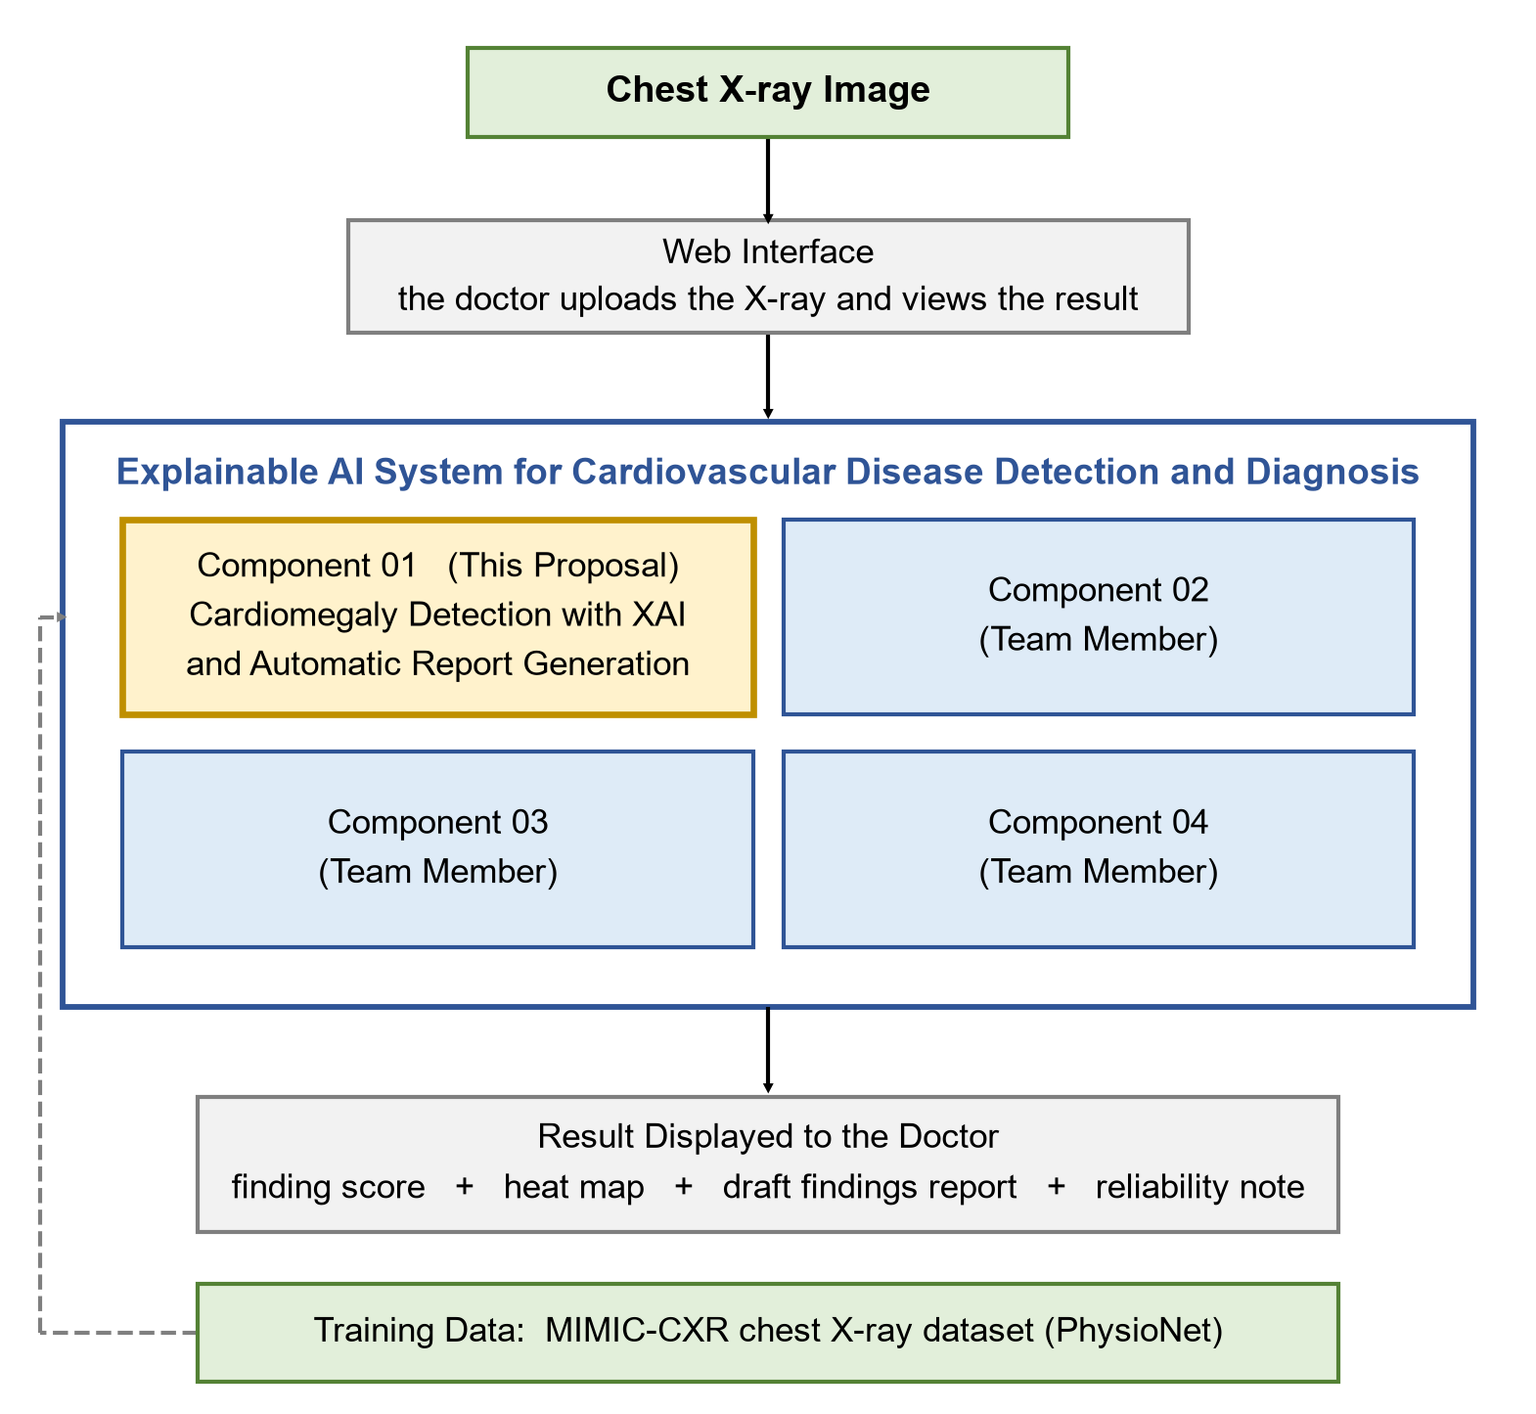
Figure 1: System diagram of components

4.3 Highlight of the Individual Component and Its Parts
Component 01 is made of five parts. The image preparation part resizes the film and corrects its brightness. The finding detection part produces a score for cardiomegaly and for each related finding. The explanation part produces the heat map. The draft report part writes a short findings paragraph from the same image features. The reliability part, which carries the new contribution of this research, compares the result against how the X-ray was taken, applies the decision level set for that type of film, attaches a plain reliability note and raises a warning when the case falls in the least reliable group. Figure 2 shows how these parts are connected.
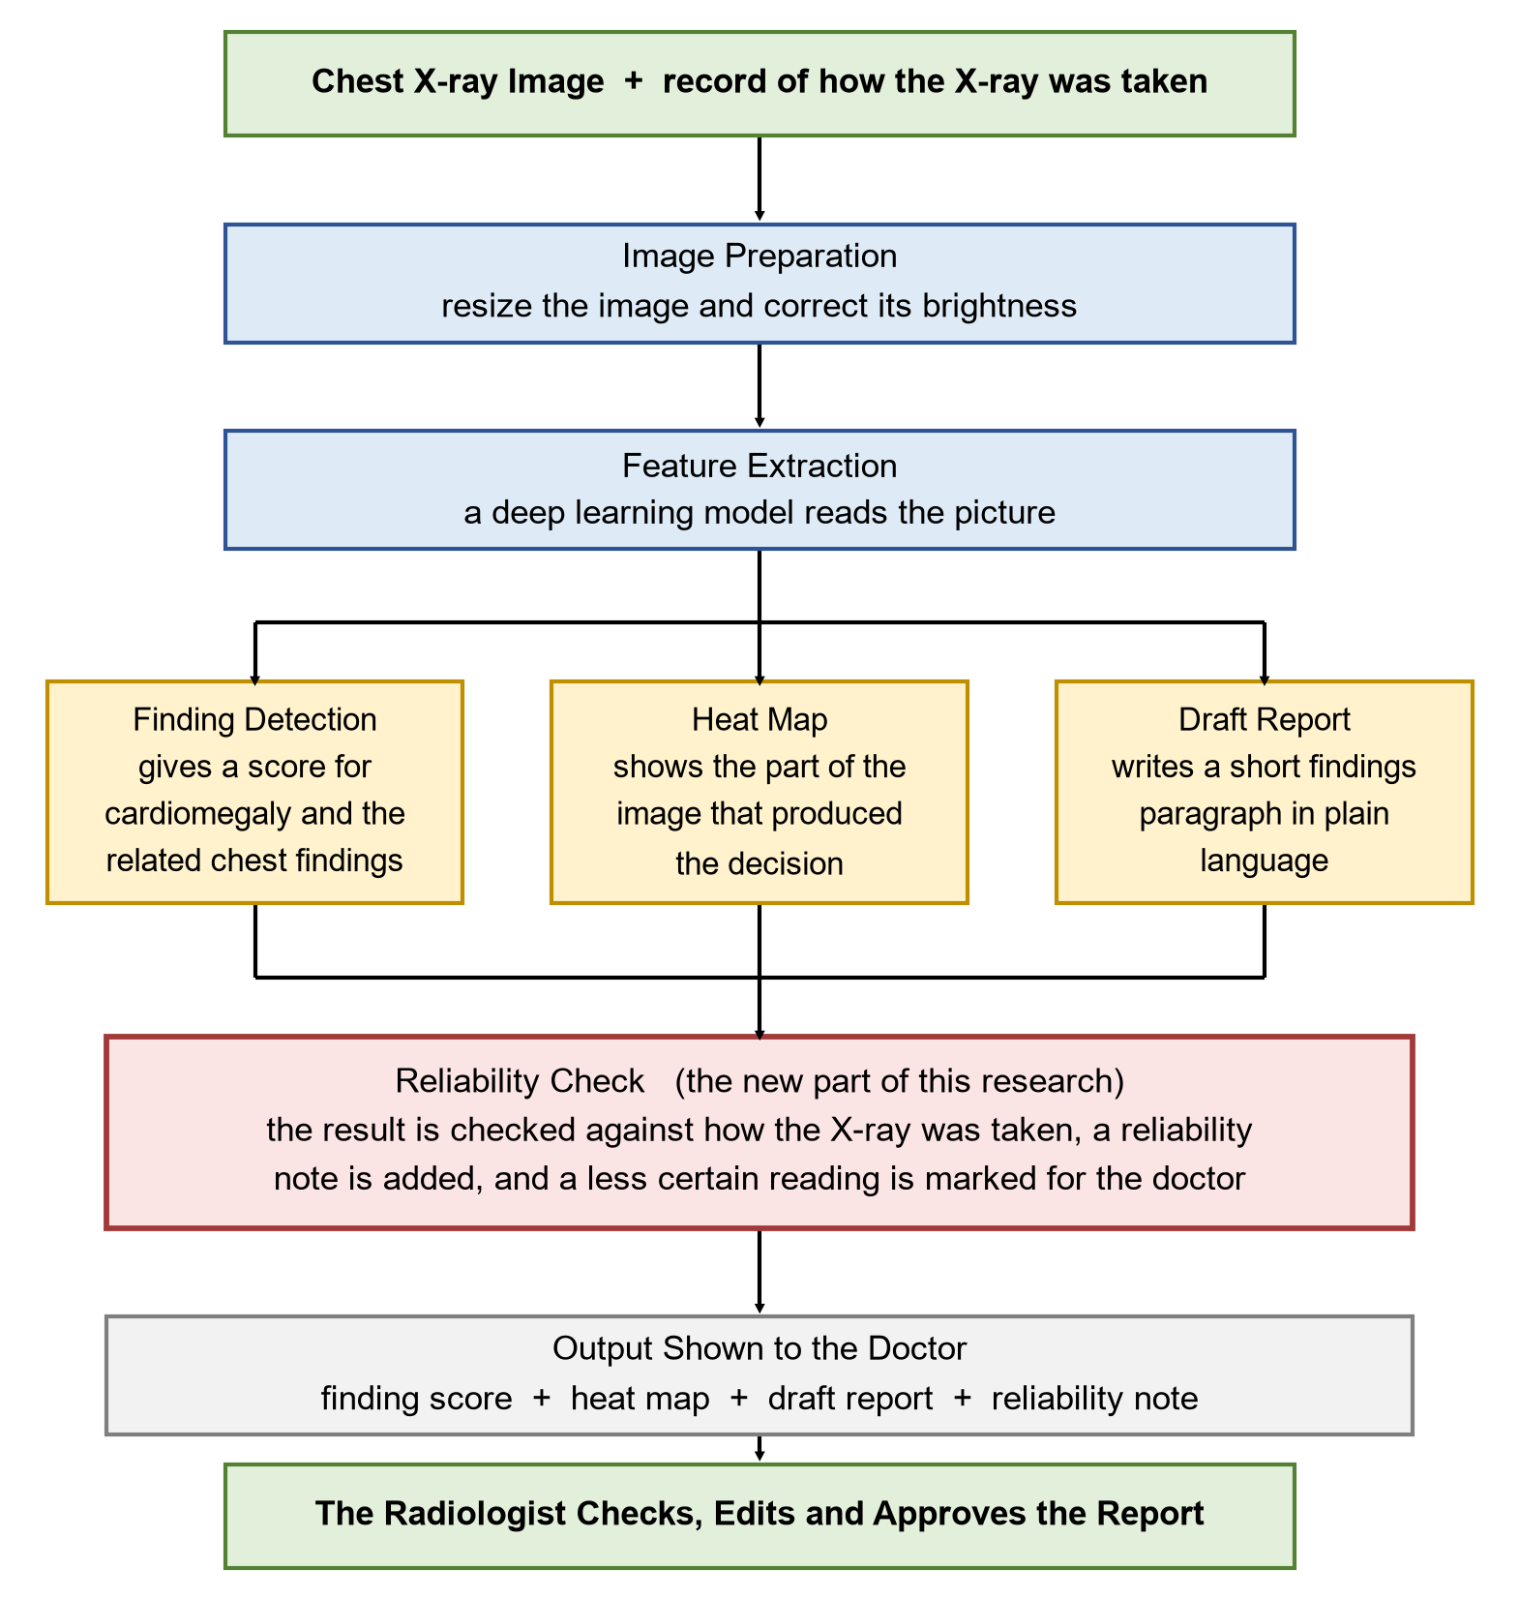
Figure 2: Data flow of the individual component

4.4 Component Interactions
Component 01 receives a prepared image and the record of how it was taken from the shared preparation step, and returns a single result object to the web service. That object holds the finding scores, the heat map, the draft findings text and the reliability note. Because everything passes through one clearly defined interface, the other components and the web interface do not need to know anything about how this component works inside, and this component can be improved later without breaking the rest of the system. When the reliability part raises a warning, the web service records it and the interface shows it on the main screen rather than hiding it in a details panel.

4.5 Data Flow Explanation
A frontal chest X-ray arrives together with the record of how it was taken. The image is checked, resized and corrected, and is then read by the deep learning model, which turns the picture into a set of values describing what is in it. Those same values feed three outputs at once: the finding scores, the heat map and the draft report text. All three, with the record of how the X-ray was taken, pass to the reliability part, which chooses the decision level suited to that type of film, assigns a reliability band and, if needed, raises the warning. The complete result is returned to the web service, stored with a log entry, and shown to the doctor, who edits and approves it. The system never issues a report on its own.

4.6 Scalability and Security Considerations
The component is designed so that each request is independent of every other, which means more copies of the service can simply be started when demand grows. The model is loaded once when the service starts rather than for every request, and several X-rays can be processed together during busy periods. The heavy work of training happens offline, so the server that runs the finished system does not need to be large.
On the security side, the interface will require a login and will restrict actions by role, so that only an authorised doctor can approve a report. Images and results will travel over encrypted connections and will be stored encrypted. Every upload, result and approval will be written to a log with the user, the time and the version of the model, so that any result can be traced back to the exact model that produced it. Research data will stay de-identified throughout, will be held only in the registered working space and will never be sent to an outside service for processing, and uploaded files will be checked before they reach the model.

5. USER REQUIREMENTS

5.1 Stakeholder Identification
Several groups will interact with the system or benefit from its results. The main users are consultant radiologists, who read and sign the report. They need a trustworthy first read, a visible reason for each finding, and a clear warning when the reading is less reliable. Junior doctors in intensive care and emergency units form the second group. They often have to act on a film before the formal report arrives, so they need an immediate indication of whether the heart looks enlarged and how far that indication can be trusted.
Radiology department managers are a third group. They decide the order in which studies are read and need a defensible rule for deciding which study is read first. Hospital information technology staff install and maintain the system and need simple deployment, activity logs and control over who can access what. Patients are the final group. They do not use the system directly, but they benefit from a faster and more consistent report and, just as importantly, they are protected from false reassurance when the reading is uncertain. The main stakeholders are therefore:
- Consultant radiologists (primary users)
- Junior doctors in intensive care and emergency units
- Radiology department managers
- Hospital information technology staff
- Patients

5.2 Functional Requirements
The proposed system shall provide the following functions:
FR1: The system shall accept a frontal chest X-ray image together with the record of how the X-ray was taken.
FR2: The system shall check the uploaded file and reject anything that is not a readable frontal chest X-ray, with a clear message to the user.
FR3: The system shall produce a score between zero and one for cardiomegaly and for each related chest finding.
FR4: The system shall produce a heat map for each detected finding and display it over the original image.
FR5: The system shall generate a short draft findings report in plain clinical language.
FR6: The generated report shall not refer to any earlier study, comparison or information that was not supplied to the system.
FR7: The system shall identify whether the X-ray was taken at the bedside or with the patient standing, and shall apply the decision level set for that type.
FR8: The system shall display a reliability note with every result, in language a doctor can act on without statistical training.
FR9: The system shall raise a review warning for any case in the least reliable group and show that warning in the result list, not only in the detailed view.
FR10: The system shall allow the doctor to edit the draft report and to approve or reject the result, and shall record every upload, result and approval in a log.
FR11: The system shall display a permanent notice stating that the output is a draft for decision support and must be reviewed by a qualified radiologist.

5.3 Non-Functional Requirements
These describe how the system should behave in real use rather than what it should do.
Performance A single X-ray should be processed and the result returned within ten seconds on the target hardware, so the doctor can use it while the patient is still being seen.
Reliability The service should recover from a failed request without losing the record of it, and should report an error rather than return a partial result.
Security and privacy Access should require a login with permissions set by role, all traffic and stored data should be encrypted, and no identifying patient information should be kept by the component.
Usability A doctor should be able to upload an X-ray, review the result and approve it without any training beyond a one-page instruction sheet.
Transparency Every result shown should be accompanied by its heat map and its reliability note; a score should never be displayed on its own.
Maintainability The code should be kept under version control, the image preparation step should exist in only one place used by both training and everyday use, and every experiment should be repeatable from a saved configuration.

6. COMMERCIALIZATION PLAN
The proposed system can be offered as a low-cost chest X-ray reading assistant for hospital radiology departments in Sri Lanka and in comparable countries, where the number of X-rays produced each day is far greater than the reading capacity available. The main target market is private hospital groups with their own imaging departments, government teaching and base hospitals reached through health ministry technology programmes, and independent diagnostic laboratories that offer imaging as a service. A typical customer is the head of a radiology department who is responsible for reporting turnaround time, has a small number of consultants, a long daily list and an intensive care unit producing bedside films at all hours.
The value the system offers is straightforward. Studies that are likely to show an enlarged heart reach a radiologist sooner, because the queue is ordered by what the system believes is urgent. The radiologist edits a prepared draft instead of writing from a blank page. The heat map lets the radiologist confirm in a second that the system looked in the right place. Most importantly, the system states when it is less reliable for a particular film, which is the feature competing products do not offer and the one a careful department will value most. Nothing about the hospital’s existing equipment has to change, because the system works from the images already being produced.
Revenue can be earned in three ways: a yearly departmental licence covering unlimited use within one department, which suits private hospital groups; a monthly charge based on the number of studies processed, which suits smaller laboratories that cannot commit to a yearly fee; and a one-off fee for installation, connection to the existing imaging system and staff training. A free research licence will be offered to universities and government teaching hospitals, both to build clinical trust and to gather local evidence. The main costs are server hosting, occasional retraining as local data builds up, support staff, and the clinical validation and regulatory work that any medical software must complete, which is normally larger than the cost of building the software itself.
Pricing would be based on the value of the reporting time saved rather than on the cost of the software, and the first installations would be offered at a reduced rate in exchange for permission to use anonymised performance data for validation, which is the usual route for a new clinical tool. Prices would sit below those of imported products, since local development, local support and the ability to retrain on local data are the main advantages available. On intellectual property, the data use agreement for the research dataset does not allow the data to be passed on, so any commercial product would have to be retrained on properly licensed data; the software itself would remain the property of the author and the university under the applicable policy; and the reliability method would be protected by publishing it in the research paper, which establishes priority while keeping the method available for clinical use.

7. BUDGET AND JUSTIFICATION
The table below sets out the estimated cost of the research phase of this component. Amounts are given in Sri Lankan Rupees.

Table 2: Estimated budget for the component
Category | Item | Estimated  Cost (LKR) | Justification
Cloud services | Graphics processing unit access for training and repeated experiments, three months | 12,000 | Training the detection model and the report writer needs a modern processor; renting one is far cheaper than buying it
Cloud services | Online storage, 200 GB for twelve months | 6,000 | The image collection and the saved models must stay available between working sessions
Hardware | External hard drive, 1 TB | 12,000 | Keeps a local copy of the dataset and protects against loss
Hardware | Development laptop | 0 (owned) | An existing machine is used for coding and writing; only training is sent to the cloud
Internet | Data usage for downloading the dataset | 8,000 | The image collection is large and has to be downloaded once
Software | Software licences | 0 | Python, PyTorch, Hugging Face, FastAPI and Git are all open source and free
Documentation | Printing, binding and poster | 5,000 | Needed for the proposal, the progress reviews and the final submission
Reserve | Contingency, about ten per cent | 4,000 | Covers price changes and unexpected costs
TOTAL |  | 47,000 | Overall estimated cost of developing and evaluating the component
In addition to these direct costs, the component is carried out by one student over about forty weeks at an average of twenty hours a week, which is roughly eight hundred hours of work. No payment is involved, but this effort is by far the largest real cost of the project and should not be treated as free. Supervision time provided by academic staff is additional to this.

8. WORK BREAKDOWN STRUCTURE (WBS)

8.1 Task Breakdown
The overall project is divided into four components, one owned by each team member, so that no component has to wait for another to be finished. The shared data preparation step is built jointly at the start. Figure 3 shows how the work of Component 01 is broken down into five stages and their main tasks.
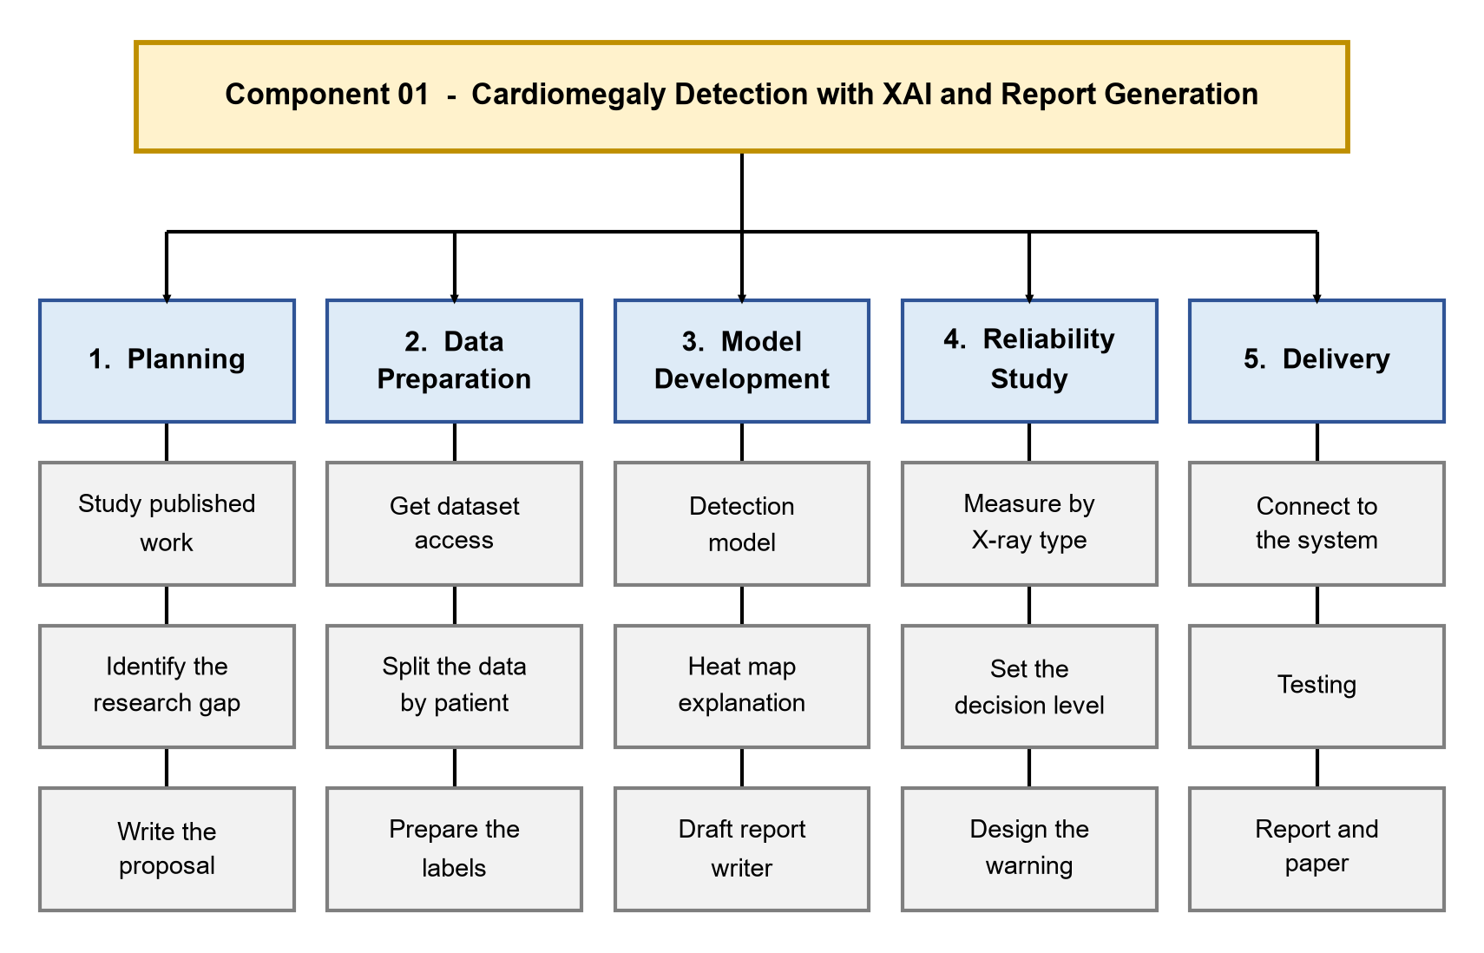
Figure 3: Task breakdown

8.2 Timeline Alignment and Workload Distribution
The five stages follow the assessment timetable of the research project. Planning and the proposal are completed before the proposal submission in March 2026. Data preparation and the first working model are completed before the first progress presentation in May 2026. The heat map, the draft report writer and the reliability study are completed before the second progress presentation at the end of August 2026. Integration, testing and the written deliverables run up to the final presentation in October 2026. The full schedule is shown in Section 9.
The workload is balanced across the team by giving each member one component of similar size, so that each has a comparable amount of data preparation, model building and evaluation to do. Beyond the individual components, all members share the work of building the common data preparation step, joining the components into one system, testing and report writing. Regular progress meetings are held to confirm that the work stays balanced and on schedule.

9. GANTT CHART
Figure 4 shows the schedule of Component 01 from November 2025 to October 2026, with the assessment milestones of the research project marked below the chart.
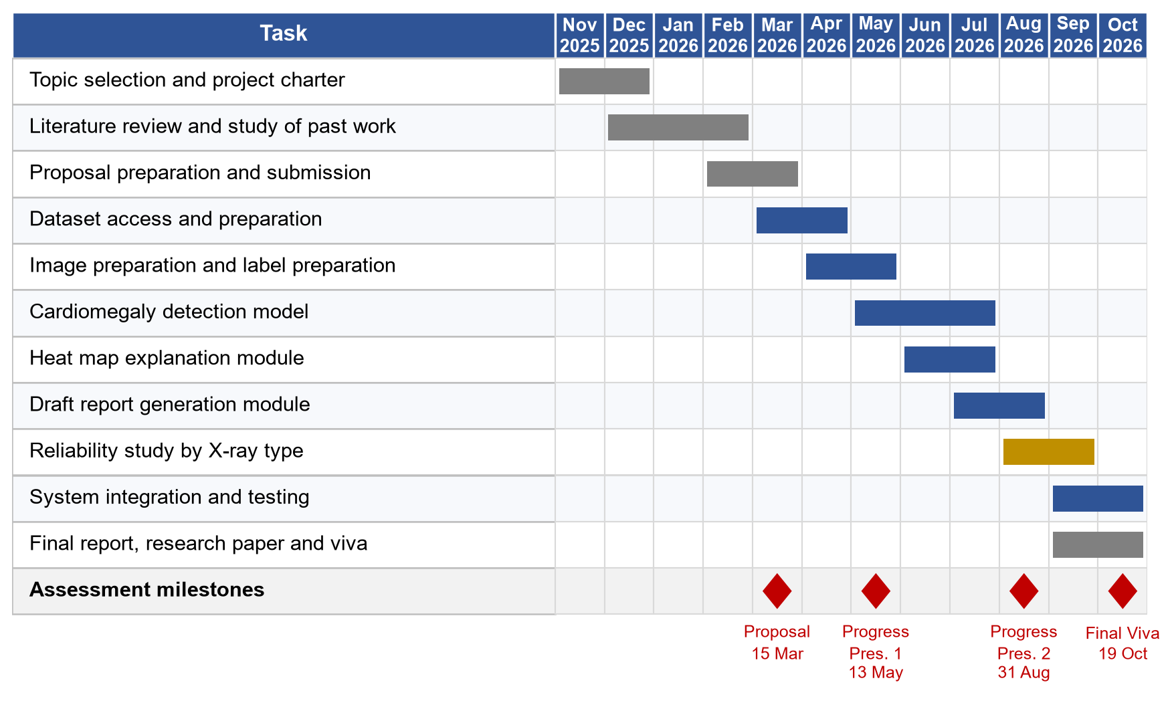
Figure 4: Gantt chart

10. REFERENCES LIST
[1] World Health Organization, “Cardiovascular diseases (CVDs),” WHO Fact Sheet, Geneva, Switzerland, 2021.
[2] Ministry of Health, Sri Lanka, Annual Health Statistics. Colombo, Sri Lanka: Medical Statistics Unit, Ministry of Health.
[3] A. E. W. Johnson, T. J. Pollard, N. R. Greenbaum, M. P. Lungren, C. Deng, Y. Peng, Z. Lu, R. G. Mark, S. J. Berkowitz and S. Horng, “MIMIC-CXR-JPG, a large publicly available database of labeled chest radiographs,” arXiv:1901.07042, 2019.
[4] J. Irvin, P. Rajpurkar, M. Ko, Y. Yu, S. Ciurea-Ilcus, C. Chute et al., “CheXpert: A large chest radiograph dataset with uncertainty labels and expert comparison,” in Proc. AAAI Conf. Artificial Intelligence, vol. 33, 2019, pp. 590–597.
[5] P. Rajpurkar, J. Irvin, K. Zhu, B. Yang, H. Mehta, T. Duan et al., “CheXNet: Radiologist-level pneumonia detection on chest X-rays with deep learning,” arXiv:1711.05225, 2017.
[6] X. Wang, Y. Peng, L. Lu, Z. Lu, M. Bagheri and R. M. Summers, “ChestX-ray8: Hospital-scale chest X-ray database and benchmarks on weakly-supervised classification and localization of common thorax diseases,” in Proc. IEEE CVPR, 2017, pp. 2097–2106.
[7] R. R. Selvaraju, M. Cogswell, A. Das, R. Vedantam, D. Parikh and D. Batra, “Grad-CAM: Visual explanations from deep networks via gradient-based localization,” in Proc. IEEE ICCV, 2017, pp. 618–626.
[8] N. Arun, N. Gaw, P. Singh, K. Chang, M. Aggarwal, B. Chen et al., “Assessing the trustworthiness of saliency maps for localizing abnormalities in medical imaging,” Radiology: Artificial Intelligence, vol. 3, no. 6, e200267, 2021.
[9] V. Ramesh, N. A. Chi and P. Rajpurkar, “Improving radiology report generation systems by removing hallucinated references to prior reports,” in Proc. Machine Learning for Healthcare Conf. (MLHC), PMLR, vol. 182, 2022, pp. 456–473.
[10] L. Seyyed-Kalantari, H. Zhang, M. B. A. McDermott, I. Y. Chen and M. Ghassemi, “Underdiagnosis bias of artificial intelligence algorithms applied to chest radiographs in under-served patient populations,” Nature Medicine, vol. 27, no. 12, pp. 2176–2182, 2021.
[11] S. C. Pereira, J. Rocha, A. Gaudio, A. Smailagic, A. Campilho and A. M. Mendonça, “Addressing chest radiograph projection bias in deep classification models,” in Proc. Medical Imaging with Deep Learning (MIDL), PMLR, vol. 227, 2024, pp. 1199–1210.
[12] J. R. Zech, M. A. Badgeley, M. Liu, A. B. Costa, J. J. Titano and E. K. Oermann, “Variable generalization performance of a deep learning model to detect pneumonia in chest radiographs: A cross-sectional study,” PLOS Medicine, vol. 15, no. 11, e1002683, 2018.

11. APPENDICES

Appendix A: Preliminary Interface Layout
The layout below is an early sketch of what the doctor will see. The aim of the design is that no score is ever shown on its own: the heat map, the draft report and the reliability note appear on the same screen as the finding scores, and the warning is placed where it cannot be missed.
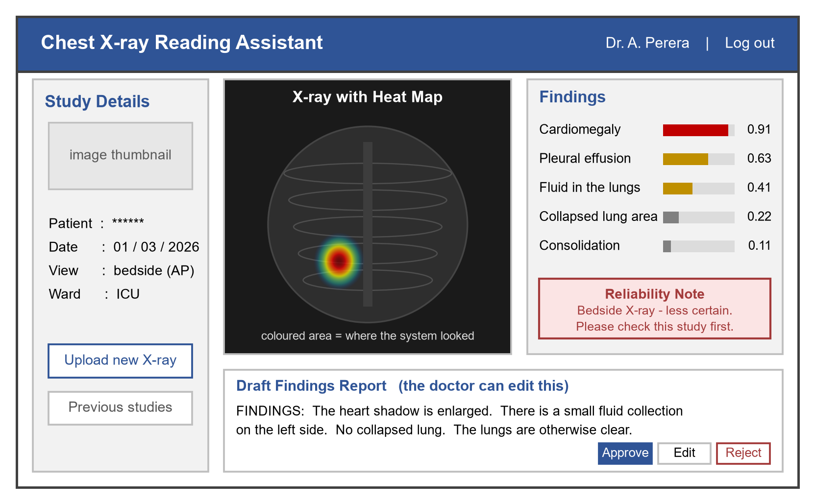
Figure 5: Preliminary interface layout

Appendix B: Risk Analysis

Table 3: Risk analysis
Risk | Likelihood | Impact | How it will be managed
Access to the dataset is delayed | Medium | High | Apply for access at the very start and build the preparation code on a smaller public collection while waiting
The cloud budget runs out before the experiments are finished | Medium | High | Run all preparation and analysis work on free processors and test every training script on a small sample first
A training session disconnects and work is lost | High | Medium | Save the model to cloud storage after every pass and resume automatically
No difference is found between the two types of X-ray | Low | Medium | A clearly measured absence of a difference is still a valid result; the reliability layer would then report equal confidence
The draft report writer does not beat the fixed sentence baseline | Medium | Medium | This is exactly why the baseline is measured; the outcome will be reported honestly and the writer presented as a draft aid only
The heat maps are unstable, as reported in [8] | Medium | Medium | Present the heat map as a check for obvious error rather than as proof, and report the assessment openly
Labels taken automatically from report text contain errors | High | Medium | Check the labels against the report text and resolve disagreements by a written rule
The model learns something about the equipment instead of the disease | Medium | High | Inspect heat maps on failure cases and test on a second collection from a different hospital
The scope grows beyond what one student can finish | Medium | High | Fix the list of findings and the deliverables at proposal stage and treat anything further as optional

Appendix C: Data Access and Ethical Documents
The following documents will be obtained and kept as evidence of proper data handling, and will be attached to the final report:
- Certificate of completion for the required online training course on working with health data.
- PhysioNet approval confirming registered access to the MIMIC-CXR dataset.
- Signed data use agreement for the dataset.
- A written statement of where the data is stored, who has access to it and how it will be destroyed at the end of the project.
- A copy of the notice shown in the prototype stating that it is a research tool and not an approved medical device.

